**Design and Prototyping of a Real Time Virtual Pathology Stethoscope Tracking System**

**Background**

Auscultation, the act of listening to the heart and lung sounds, can reveal substantial information about patients’ health and other cardiac related problems; therefore, competent training can be a key for accurate and reliable diagnosis. Standardized patients (SPs), who are healthy individuals trained to portray real patients, have been extensively used for such training and other medical teaching techniques; however, the range of symptoms and conditions they can simulate stays limited since they are health patient actors.

A hybrid method that couples SPs and virtual pathology stethoscope (VPS) would extend the capabilities of SPs and allow medical trainees to hear abnormal heart and lung sounds in a normal SP. A critical component of such hybrid simulations is real time and accurate detection of common auscultation areas before overlaying abnormal auscultatory findings on the otherwise heath SP.

In this work, we propose a novel tracking method for placing virtual symptoms in correct auscultation areas based on recorded ECG signals with various stethoscope chest piece orientations. The proposed system provides an efficient, non-invasive, and cost efficient method for tracking VPS and extending the realism in simulation based auscultation training.

**Project Description**

The objective of this project is to design and implement a prototype of an integrated biometric system based on Raspberry Pi microcomputer system.

The work consists of two parts:

1. Designing an ECG analysis prototype that can perform real-time classification by utilizing embedded machine learning algorithms.

2. Developing an embedded system for receiving ECG and performing online classification (detection) of the auscultation areas.

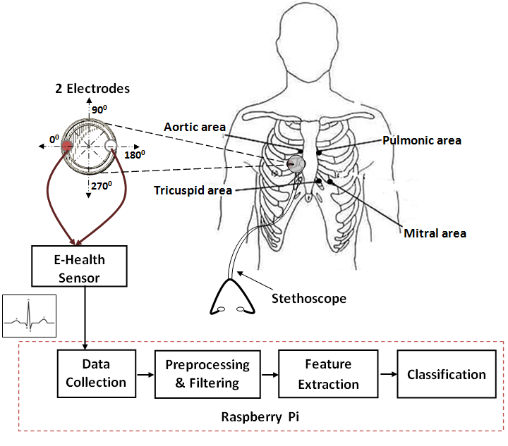

Figure 1 : Proposed Real-time ECG-based VPS tracker.

The VPS tracking system involves processing ECG signals and extracting relevant features which are then used for learning and predicting correct auscultation areas over the SP chest. Our proposed embedded learning approach is primary constricted by memory, CPU, Battery and commination bandwidth. However, many instance based learning algorithms (e.g support vector machines, fast random forest), have shown impressive results on current generation microprocessors and can address these constraints.

**Embedded system: Raspberry Pi**

The Raspberry Pi is a tiny and inexpensive ($25-$35) single board computer platform used for embedded systems education and experimentation. This 2 by 3 inch board uses a Broadcom 700 MHz processor that can be overclocked to a maximum of 1 GHz. The recent model B version has 512MB RAM and includes both USB 2.0 and Ethernet connection. The operating platform is linux based with multiple supports for c/c++ coding.

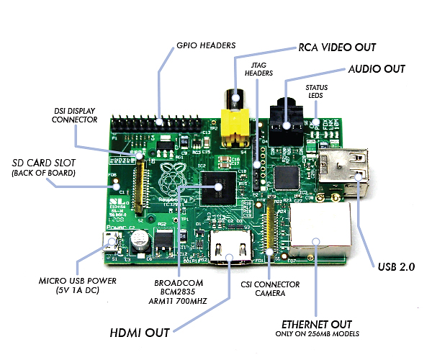

Figure 2 Raspberry Pi.

Raspberry Pi’s processing power which is comparable to 300MHz Pentium 3 is ideal for the type of ECG signal processing and classification we wish to conduct. Our intent is to provide high realism and increase the likelihood of trainees to suspend disbelief; therefore, an immediate and accurate identification of the auscultation areas is critical for fully immersive simulation experience.

**Sensors: E-Health Sensor Platform for Raspberry Pi**

The e-Health sensor shield (figure 3) extends the sensing capabilities of the Raspberry Pi by allowing it to easily connect though nine different biometric sensors: pulse, oxygen in blood (SPO2), airflow (breathing), body temperature, electrocardiogram (ECG), glucometer, galvanic skin response (GSR - sweating), blood pressure (sphygmomanometer) and patient position (accelerometer). This integrated platform coupled with the Raspberry Pi would serve as a test bed for assessing the performance of proposed real time VPS tracking system.

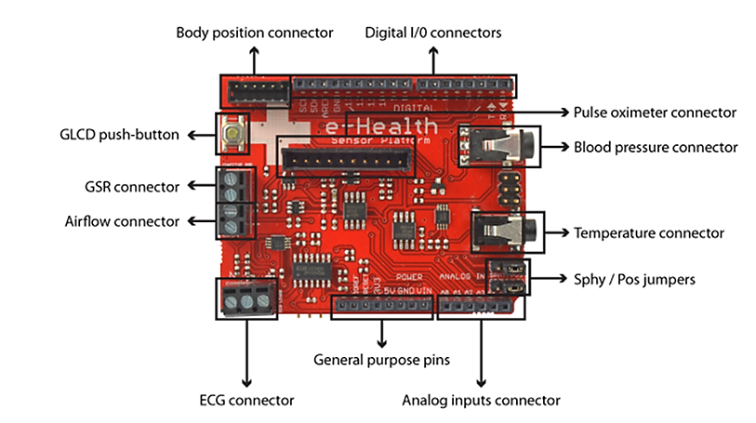

Figure 3 : e-Health Sensor Platform

The sensor platform uses different wireless connectivity options – such as Wi-Fi, 3G, and Bluetooth— to transmit information to personal computers, smartphones or cloud based services. This can be applicable for real-time data analysis or highly immersive hybrid simulations. The e-heath sensor is fully compliable with raspberry pi and includes high level C++ library for interfacing and recording inputs from the various sensors.

**Hardware requirements and cost breakdown**

For this project, we have identified four sensors and two wireless connections schemes to test our stethoscope tracking system and also assess the applications of other biosensors in improving the hybrid simulation. Additional requirements and related cost estimate are shown on the tables below.

|  |  |  |
| --- | --- | --- |
| Sensors and peripherals | Description | Picture |
| Raspberry PI to Arduino shield (Required ) | Raspberry Pi to Arduino shields connection bridge allows any Arduino board or module to connect with Raspberry Pi | raspberry_e_heatlh |
| Electrocardiogram (ECG) sensors | Three Lead ECG electrodes for detecting electrical actives of the heart. | parches presentación |
| Patient position sensor ( Accelerometer) | Position sensor accelerometer with selectable full scale ( ±2g/±4g/±8g) high pass filtered data as well as non-filtered data for real-time analysis. | pulsometro_pecho_presentacion |
| Airflow sensor (Breathing sensor ) | Nasal / mouth airflow sensor is a device used to measure the breathing rate in a patient in need of respiratory help. | canula_presentacion |
| Pulse and Oxygen in Blood sensor (SPO2) | Pulse oximetry a noninvasive method of indicating the arterial oxygen saturation of functional hemoglobin. The bloodstream is affected by the concentration of HbO2 and Hb, and their absorption coefficients are measured using two wavelengths 660 nm (red light spectra) and 940 nm (infrared light spectra). | pulsometro |
| Bluetooth Module | Bluetooth v2.1 with WT12 chipset with and rang off 10 to 50 meters depending in the environment | Bluetooth module PRO for Arduino |
| wireless LAN access device (RN-XV) | The RN-XV module is based upon Roving Networks' robust RN-171 Wi-Fi module and incorporates 802.11 b/g radio, 32 bit processor, TCP/IP stack, real-time clock, crypto accelerator, power management unit and analog sensor interface |  |
| Serial Graphic LCD 128X64 | The Serial Graphic LCD backpack is soldered to the 128x64 pixel Graphic LCD and provides the user a simple serial interface | pantalla5 |

|  |  |  |  |  |  |
| --- | --- | --- | --- | --- | --- |
| **Item** | **Main Board** | **Web Link** | **Price**  **per unit** | **Quantity** | **Total** |
| 1 | Raspberry PI (RASPBRRY-MODB-512M) | <http://www.newark.com/jsp/search/productdetail.jsp?sku=43W5302> | $ 35.00 | 1 | $ 35.00 |
| 2 | SD card (SAMSUNG - PROG-4GB-SDCARD - PRE PROGRAMMED) | <http://www.newark.com/jsp/search/productdetail.jsp?sku=96T7436> | $ 12.46 | 1 | $ 12.46 |
| 3 | USB port power supply (ADAFRUIT INDUSTRIES - 501) | <http://www.newark.com/adafruit-industries/501/usb-port-power-supply-ac-adapter/dp/44W4932> | $ 5.95 | 1 | $ 5.95 |
|  | **Raspberry Pi** | ***Total*** |  |  | **$53.411** |
|  |  |  |  |  |  |
| **Item** | **e-Health Shields and Sensor Platforms** | **Model Number** | **Price per unit** | **Quantity** | **Total** |
| 1 | e-Health Sensor Shield | <http://www.cooking-hacks.com/index.php/ehealth-sensor-shield-biometric-medical-arduino-raspberry-pi.html> | € 75.00 | 1 | € 75.00 |
| 2 | Raspberry PI to Arduino shield | <http://www.cooking-hacks.com/index.php/raspberry-pi-to-arduino-shield-connection-bridge.html> | € 40.00 | 1 | € 0.00 |
| 3 | Electrocardiogram (ECG) sensors | <http://www.cooking-hacks.com/index.php/electrocardiogram-sensor-ecg-ehealth-medical.html> | € 35.00 | 1 | € 35.00 |
| 4 | Patient position sensor ( Accelerometer) | <http://www.cooking-hacks.com/index.php/patient-position-sensor-accelerometer-ehealth-medical.html> | € 40.00 | 1 | € 40.00 |
| 5 | Airflow sensor (Breathing sensor ) | <http://www.cooking-hacks.com/index.php/airflow-sensor-breathing-ehealth-medical.html> | € 25.00 | 1 | € 25.00 |
| 6 | Pulse and Oxygen in Blood sensor (SPO2) | <http://www.cooking-hacks.com/index.php/pulse-and-oxygen-in-blood-sensor-spo2-ehealth-medical.html> | € 55.00 | 1 | € 55.00 |
| 7 | Bluetooth Module | <http://www.cooking-hacks.com/index.php/bluetooth-module-pro-for-arduino.html> | € 75.00 | 1 | € 75.00 |
| 8 | wireless LAN access device (RN-XV) | <http://www.cooking-hacks.com/index.php/wifi-module-for-arduino-roving-rn-xvee-xbee-compatible.html> | € 40.00 | 1 | € 40.00 |
| 9 | Serial Graphic LCD 128X64 | <http://www.cooking-hacks.com/index.php/serial-graphic-lcd-128x64.html> | € 29.90 | 1 | € 29.90 |
|  | **Biomedical sensor platform** | ***Total*** |  | ***In euros*** | **€ 414.90** |
|  |  |  |  | ***In dollars*** | **$ 544.14** |
|  |  |  |  |  |  |
|  | **TOTAL COST ESTIMATE** |  |  |  | **$ 597.55** |

**HARDWARE COST ESTIMATE**